Version 1.0
Packserv Quick Set Up Guide: AV-3
AV-3 Bench Top Single Head Filler

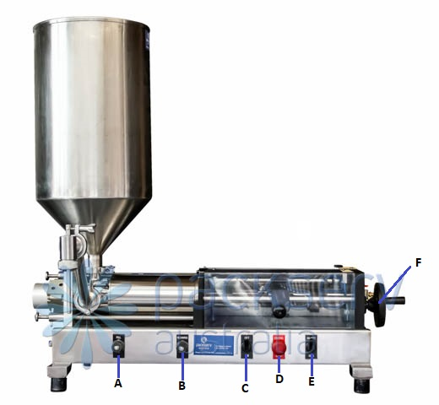

Assigned Letter | Part Name | Description
A | Fill Knob | Adjusts the filling rate. Turn clockwise to slow the fill rate. Turn anti-clockwise to increase the fill rate. Adjust to avoid excessive product turbulence and/or foaming.
B | Recharge Knob | Adjusts the recharge rate. Turn clockwise to slow the recharge rate. Turn anti-clockwise to increase the recharge rate. Adjust to allow adequate time to exchange the filled container with an empty one. *Please note that viscous products (i.e. honey) require a slower recharge rate so an air cavity doesn’t form in the cylinder leading to inaccurate volumes being dispensed.

C | On/Off Switch | Primary switch for starting and stopping the machine. Should be set to on in normal conditions.  *Please note when using in conjunction with a footswitch must be set to off.
D | Emergency Stop | In event of spillage or an accident use this. When pressed the product valve returns to the inlet position and all air is exhausted from the main cylinder. Turn to right to release the button.  *Please note, set On/Off switch to Off before releasing.
E | Adjust/Run Switch | Allows adjustment of cylinder volume to be made. During normal machine function should be set to Run. To adjust volume of product dispensed set to Adjust & On. Piston head will stop at final charge position. Use Volume Adjustment Handle to alter final volume.  *Please note to have a container under nozzle prior to adjustment.
F | Volume Adjustment Handle | Loosen the black knurled lock ring (turn anti-clockwise). Turn the handwheel clockwise to increase volume and vice-versa.  *Please note that an accurate representation of volume will only be apparent after continuous cycling (~10 units) so complete a weigh check after several units have been produced at production speed.

Machine Setup
- Before connecting the airline to the machine set the required volume using part F. To set the amount of liquid ejected from machine use the scale of 1 to 10 on the top of the machine to determine the required percentage of the cylinder you have i.e. 1 represents 10% of maximum cylinder volume, 5 represents 50% of maximum cylinder volume. Turn handle clockwise to increase, anticlockwise to decrease, ensure you lock the hand wheel with the black locking ring next to it once in desired position to prevent movement during production.
- Connect air to the machine and turn red valve on at the back until it says ‘SUP’ (i.e. ‘wings’ are in line with airline). The pressure gauge at the back of the machine should be on around 4-5 bar.
- Place all required wet parts on the machine to suit current product. Cycle the machine until all air has been removed from the circuit. In some cases re-positioning product inlet hose may be necessary. To cycle machine switches should be set to: On (C) & Run (E) (with emergency stop released).
- Check if desired amount of product is rejected by placing an empty container on a scale then tare the unit. Dispense the product into container then re-weigh. If adjustment is required set machine to Adjust (E) and Run (C). Please note that there can be variation in the weight of containers so this could be a cause of inconsistencies.
*To avoid wastage once you’ve adjusted the volume, set the switch to Run then quickly switch back to Adjust so you can check the volume being dispensed and won’t have to waste another unit if it’s inaccurate.
- Once desired weight has been achieved to run the machine automatically place switches in On and Run positions. If using the foot pedal leave the machine in Off and Run positions.

Machine Speed Setting
- Increase the fill speed by manipulating the ‘Fill’ (A) knob. The rate at which the product enters the container should be adjusted so that the container is filled as quickly as possible without excessive product turbulence/foaming. This rate is affected by a number of variables (i.e. nozzle diameter, product viscosity, orifice opening on container) so the optimal speed must be achieved through trial and error.
- To alter the recharge speed manipulate the ‘Recharge’ knob (B). The ideal speed for the recharge should allow the operator enough time to get a new container in place before a new cycle begins. In some scenarios (depending upon product viscosity) the recharge speed must be set to prevent ‘cavitation’ within the product cylinder. This occurs when the piston head recharges faster than the product is capable of entering the cylinder barrel e.g. if honey is being pulled in on a cold day it will enter the cylinder much slower than the piston head can move thus this must be accounted for otherwise inaccurate product dispense will occur.

AV-3 Cleaning Guide
- Undo the clamp holding the metal hopper or inlet assembly on top of the machine and remove, don’t misplace the seal connecting the two flanges.
- Undo the clamp holding the gooseneck and nozzle in place and gently set down, again don’t misplace the seal connecting these pieces.
- Separate the gooseneck and nozzle by undoing the clamp holding them together, be aware of the seal here.
- Undo the two wing nuts on the left side of the machine and pull silver plate towards them.
- Open the clear plastic cover and remove the locking pin (Part D, Figure 1) in the cylinder rod (Part C, Figure 1).
- Pull out the whole wet assembly including the cylinder and valve body (Figure 1 & 2).
- Separate the valve body and cylinder gently, be careful to not drop transition plate (Part A, Figure 1) at this point.
- Push rotary valve (Part D, Figure 2) out from valve body (Part C, Figure 2).
- Remove both the transition plate (Part A, Figure 1) and the end cap (Part E, Figure 1) from both ends of the cylinder, and pull piston (Part C, Figure 1) out of the cylinder (Part B, Figure 1). *Piston head can be difficult to remove at times, gently pivot back and forth whilst pulling to make it easier.
- Attach a shifter to the piston head (Part C, Figure 1) and another shifter to the cylinder rod (Part C, Figure 1) and remove piston head to get to piston head seals. *Note only if products are vastly different between jobs is this required to be separated and cleaned
- Remove metal locking plate, thin support ring, plastic glide ring, O ring and the second thicker support ring.
- Use a small screwdriver to remove all the O rings on the transition plate, rotary valve, and nozzle, be very careful not to nick or scratch the seals or parts.
- Place all parts in dishwasher, or wash by hand in warm soapy water.
- To reassemble follow the above steps in reverse, make sure to lubricate all O rings with food grade grease.

Notes
- If machine doesn’t run when you put switches into on and run positions check pressure gauge at rear (should read 400-500kpa), close Perspex cover, check emergency stop button is released (turn clockwise), reduce the volume adjustment so the sensor touches the black aluminum plate, or wind out (anticlockwise) run and recharge flow controls.
- It is a good idea to periodically check the fill volume during your production run in case there is a variation.
- When using a Positive Shut-Off (PSO) Nozzle ensure that the airlines are connected to the rear two ports of the machine on the left hand side (i.e. the back of the machine).
- When using a foot pedal ensure that the airlines are connected to the front two ports of the machine on the left hand side (i.e. front of the machine).
- The airlines plugged into the top of the PSO air cylinder should correspond to if the nozzle has an inward opening or outward opening attachment i.e.:
  - Inward Opening Nozzle: Blue airline on top and Black airline underneath.
  - Outward Opening Nozzle: Black airline on top and Blue airline underneath.

Safety
- To ensure safe operation please be aware of pinch points, spills and possible hazards around the machine.
- Do not put your face or other sensitive body parts near the machine while operating.
- If there is an accident or the machine needs to be stopped quickly press the emergency stop button or remove the airline immediately.
- Wear all company specified personal protective equipment while operating the machine including safety glasses.
- Do not operate the machine whilst under the influence of drugs and or alcohol.
- Always observe all safety warnings and notices on the machine, do not remove any covers, disconnect any airlines or attempt any repairs of the machine, only qualified trained technical staff should perform any repairs and only with our written permission.
- Do not use flammable or toxic cleaning fluids such as petrol or benzene to clean the machine.
- Keep your face, hands and fingers out of the filling area.

Additional Images

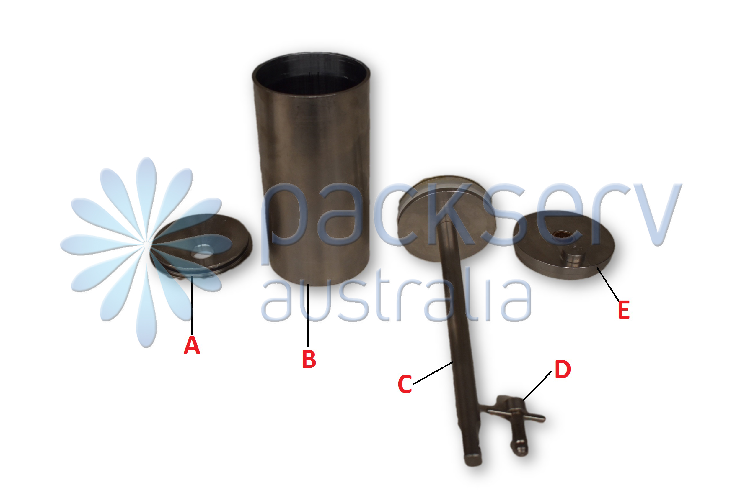
Figure 1: 1250ml Cylinder, Deconstructed
Assigned Letter | Name
A | Transition Plate
B | Cylinder Barrel
C | Piston Rod/Head
D | Locking Pin
E | End Plate

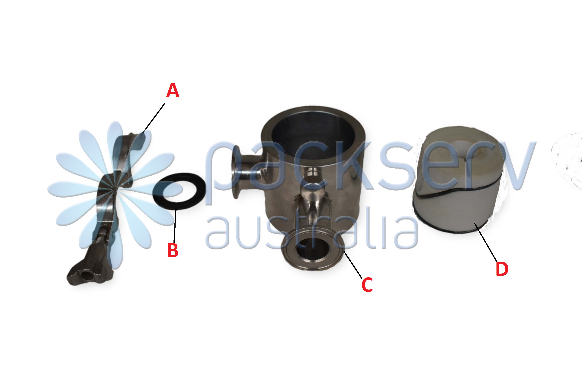
Figure 2: Rotary Valve, Deconstructed
Assigned Letter | Name
A | Clamp
B | Triclover Seal
C | Valve Body
D | Valve with Seals

